# Precipitation tools

## Purpose

This module offers a set of functions to calculate drought indices for NDVI time series. These functions are:

* Calculate *standardized precipitation index* (SPI)
* Classify the SPI drought index

## Installation

Install the .sav files in the save_add folder (see also [ENVI .sav files: Installation and configuration](http://www.itc.nl/personal/nieuwenh/installations.html).

nrsmenu.pro Define NRS menu item in ENVI

nrs_Utils.sav Library with utility routines

nrs_precipitation_tools.sav The actual software

## Usage (gui)

|  |  |
| --- | --- |
| NRS_SPI_GUI | Start the user interface of the normalizing. |
| NRS_DROUGHT_GUI | Start the user interface of the drought index calculation. |

Alternatively the commands can be started from the ENVI menu: ‘NRS | Precipitation:



### Calculate Standardized Precipitation Index (SPI)

Menu option is ‘NRS | Precipitation | Calculate SPI, the command line is ‘nrs_spi_gui’. This function is based on the algorithm developed by (McKee, Doesken et al. 1993). A probability density function is fitted over a frequency distribution of precipitation for a certain time scale. The found probability function is then transformed into a standard normal distribution.

Because of the nature of the algorithm for time scales larger than one month the first months (time scale – 1) in the time series will be undefined.

Below is the user interface:

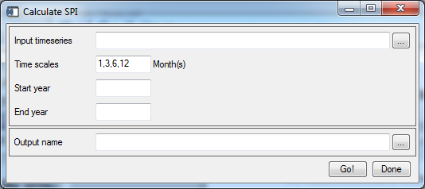

Explanation of all the fields:

|  |  |
| --- | --- |
| Input time series | Select an input precipitation time series; the time step must be monthly! |
| Time scales | A comma-separated list of time scales (in months). The SPI is calculated for each of the time scales |
| Start year | The starting year (starting at January) |
| End year | The ending year (ends at December) |
| Output series | The base filename for the output time series. The software will generate one file for each time scale. |

The input data is assumed to contain monthly precipitation values. Negative values indicate dry conditions, positive values wet conditions.

See the section on the classification for more information on the meaning of the SPI values

The software can generate more than one output file. The output file names will end with the time scale for which it was generated. So if the output base filename is twente, and the spi is calculated for three time scales, say 1, 3 and 6 months, the software generates three files: twente01, twente03 and twente06.

### Classify SPI

Menu option is ‘NRS | Precipitation | Classify SPI, the command line is ‘nrs_drought_gui’. This function takes the output SPI values and classifies them according to the table below.

|  |  |
| --- | --- |
| SPI | Class |
| > 2 | Extremely wet |
| 1.5 – 1.99 | Severely wet |
| 1.0 – 1.49 | Moderately wet |
| -0.99 – 0.99 | Normal |
| -1.0 – -1.49 | Moderately dry |
| -1.5 – -1.99 | Severely dry |
| < -2 | Extremely dry |

The software generates a time series with all bands classified according to the table.

The user interface is shown below:

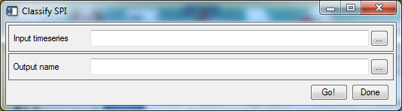

Explanation of all the fields:

|  |  |
| --- | --- |
| Input time series | Select an input SPI time series |
| Output name | The filename for the output classified time series. |

### References

McKee, T. B., N. J. Doesken, et al. (1993). The relationship of drought frequency and duration to time scales. Proceedings of the 8th Conference of Applied Climatology. Anaheim, California**:** 6.